**Root Cause Analysis - Manufacturing Sector**

GOKULNATH K & E24755

**Overview**

Root Cause Analysis (RCA) in the manufacturing sector is a systematic approach used to identify the underlying reasons for defects, failures, or inefficiencies in production processes. In data analysis, RCA involves collecting and analyzing data related to production metrics, quality control, equipment performance, and other relevant factors to uncover patterns and correlations that point to the root causes of issues. Techniques such as Pareto analysis, Fishbone diagrams (Ishikawa), and the "5 Whys" method are commonly employed to drill down from symptoms to the core problem. The goal of RCA is not only to address the immediate issue but also to implement long-term corrective actions that prevent recurrence, thus improving overall operational efficiency, reducing downtime, and enhancing product quality. For data analysts in manufacturing, RCA is crucial as it helps in transforming raw data into actionable insights, driving continuous improvement, and supporting decision-making processes that lead to optimized production workflows and reduced costs.

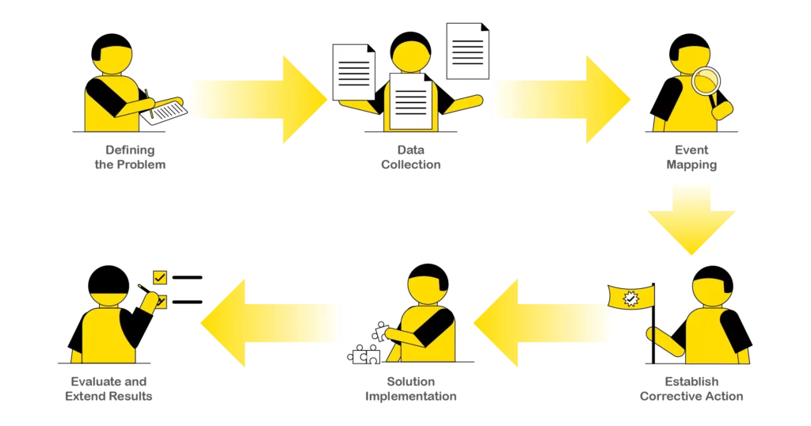

**Objective**

### **1. Identify the Primary Causes of Defects or Failures**

The core objective of RCA is to discover the exact reasons behind recurring issues such as defects, equipment failures, or inefficiencies. By analyzing data, manufacturers can trace these issues to their root causes, whether they involve equipment malfunction, human error, material defects, or process flaws.

### **2. Prevent Recurrence of Issues**

RCA aims to implement corrective actions that permanently eliminate identified issues. The goal is not just to fix the immediate problem but to ensure it does not happen again, thereby improving the long-term stability of production processes.

### **3. Optimize Production Processes**

Using data-driven insights, RCA seeks to refine and enhance manufacturing processes. This involves identifying bottlenecks, waste, and inefficiencies, and then re-engineering processes to optimize performance, reduce costs, and increase output.

### **4. Improve Product Quality**

RCA is critical for identifying and mitigating factors that negatively impact product quality. Addressing the root causes of quality issues ensures that products meet or exceed customer expectations, leading to higher customer satisfaction and reduced instances of returns or rework.

### **5. Enhance Safety and Compliance**

Improving workplace safety is another key objective of RCA, as it identifies the root causes of accidents or near-misses. Additionally, RCA ensures compliance with industry standards and regulations by addressing any underlying issues that could lead to non-compliance.

### **6. Reduce Downtime and Maintenance Costs**

By analyzing data related to equipment performance, RCA identifies the root causes of frequent breakdowns or maintenance issues. Addressing these causes results in reduced downtime, lower maintenance costs, and extended equipment lifespan.

### 

### 

### **7. Support Data-Driven Decision Making**

RCA encourages the use of data and analytics in decision-making processes. By relying on data to uncover root causes and validate corrective actions, manufacturers can make more informed and effective decisions that drive continuous improvement.

### **8. Foster a Culture of Continuous Improvement**

RCA promotes a proactive approach to problem-solving and continuous improvement within the organization. By regularly conducting RCA and acting on its findings, manufacturers can cultivate a culture that values data-driven insights and strives for excellence in all aspects of production.

**Assigned Task(s)**

* Root Cause Analysis - Manufacturing Sector

**Task Details**

* **Task 13:** Root Cause Analysis (RCA) in the manufacturing sector for data analysis is a methodical approach to identifying the underlying reasons for defects, inefficiencies, or failures in production. It involves analyzing data related to equipment performance, process flows, and quality metrics to trace issues back to their origin. The goal is to implement corrective actions that prevent recurrence, optimize processes, and improve overall product quality. By using data-driven insights, RCA supports continuous improvement and enhances decision-making.
* **Status:** Completed
* **Details:** Root cause analysis (RCA) in the manufacturing sector is a crucial process used to identify the underlying reasons for defects or issues within production systems. This method involves systematically investigating the problem to uncover its origin, rather than merely addressing the symptoms. Effective RCA typically starts with data collection from various sources, including production records, quality reports, and machine logs. Data analysis techniques such as statistical analysis, process mapping, and failure mode effects analysis (FMEA) are employed to pinpoint the exact causes of production failures or inefficiencies. By understanding these root causes, manufacturers can implement targeted corrective actions to improve process reliability, reduce downtime, and enhance product quality. RCA not only helps in resolving current issues but also in preventing future problems, thereby contributing to overall operational excellence and cost efficiency.

**Progress**

* **Accomplishments:** To accomplish root cause analysis (RCA) in the manufacturing sector, begin by clearly defining the problem and gathering comprehensive data related to the issue. This data should include production logs, quality control reports, and any other relevant information. Next, use analytical techniques such as statistical analysis to identify patterns and correlations that may point to potential causes. Employ tools like fishbone diagrams, 5 Whys, or failure mode effects analysis (FMEA) to systematically explore and eliminate possible causes. Engage with cross-functional teams, including operators, engineers, and quality control personnel, to gain diverse perspectives and insights. Once the root cause is identified, develop and implement corrective actions to address it. Monitor the effectiveness of these actions through ongoing data collection and analysis to ensure the problem is resolved and to prevent recurrence. This approach not only addresses current issues but also fosters continuous improvement in manufacturing processes.
* **Metrics:** Incorporating metrics into root cause analysis (RCA) in the manufacturing sector involves using quantitative measures to support the identification and resolution of issues. Begin by defining relevant metrics, such as defect rates, production downtime, cycle times, and process yields, which can provide insights into where problems are occurring. Collect data on these metrics to establish a baseline and identify deviations from normal performance. Analyze this data to detect trends, patterns, or anomalies that may indicate underlying causes. During the RCA process, use these metrics to quantify the impact of potential root causes and assess the effectiveness of corrective actions. By integrating metrics into the analysis, you can make data-driven decisions, prioritize issues based on their impact, and track improvements over time. This approach ensures that the root cause analysis is grounded in objective evidence, leading to more accurate problem identification and effective solutions.

**Challenges and Solutions**

* **Challenges Faced:**

1. Inaccurate, incomplete, or inconsistent data can lead to incorrect conclusions during RCA.
2. Manufacturing processes often involve complex interactions between machines, materials, and human factors, making it difficult to pinpoint root causes.
3. Not having the right metrics or KPIs can hinder the ability to identify the root cause of problems.
4. RCA may be limited by poor communication and collaboration among team members from different departments.
5. Employees or management may resist changes suggested by the RCA process, impacting the implementation of corrective actions.
6. Even after identifying root causes, implementing and sustaining corrective actions can be difficult.
7. Without proper follow-up, there’s a risk that the identified issues may reoccur or new problems may arise.
8. RCA may focus too narrowly on specific issues without considering broader systemic factors.

* **Solutions Implemented:**

1. Implement rigorous data validation and cleaning processes. Ensure regular maintenance and calibration of data collection systems. Establish clear data governance policies to maintain data integrity.
2. Use advanced analytical tools and techniques such as statistical process control (SPC), process mapping, and simulation models to better understand and visualize complex systems. Break down the process into smaller, manageable components for more focused analysis.
3. Develop and monitor relevant metrics that are aligned with the manufacturing goals. Use metrics such as defect rates, cycle times, and downtime to provide insight into performance issues.
4. Foster a culture of open communication and teamwork. Create cross-functional teams involving personnel from engineering, production, quality control, and other relevant areas to ensure a holistic approach to problem-solving.
5. Engage stakeholders early in the RCA process and provide clear, evidence-based recommendations. Offer training and support to help employees adapt to new processes or changes.
6. Develop a detailed action plan with clear responsibilities, timelines, and follow-up procedures. Monitor the implementation of corrective actions and adjust as necessary to ensure they are effective.
7. Establish a robust monitoring system to track the effectiveness of implemented solutions. Use metrics to continuously assess performance and make iterative improvements.
8. Use a comprehensive approach that considers both specific issues and broader systemic factors. Employ tools such as the 5 Whys or fishbone diagrams to ensure a thorough investigation.

**Next Steps**

* **Upcoming Tasks:** To address upcoming tasks in manufacturing data analysis, focus on setting clear objectives and gathering accurate data. Use sophisticated analytical methods to interpret data effectively. Work collaboratively with various departments to implement and monitor actionable solutions.
* **Goals:** To set clear goals for upcoming tasks in the manufacturing sector, start by defining specific, measurable objectives that align with overall business targets. Identify key performance indicators (KPIs) to track progress and set realistic deadlines. Ensure goals are communicated effectively to all relevant stakeholders, and establish a plan for regular reviews and adjustments as needed.

**Conclusion**

* **Summary:** In the manufacturing sector, root cause analysis (RCA) is essential for identifying and addressing underlying issues impacting production efficiency and quality. By systematically collecting and analyzing data, using relevant metrics, and engaging cross-functional teams, RCA helps pinpoint the core problems rather than just treating symptoms. Overcoming challenges such as data quality issues, complexity, and resistance to change involves implementing robust data collection practices, employing advanced analytical tools, and fostering effective communication. Successful RCA leads to targeted corrective actions, continuous monitoring, and sustained improvements, ultimately enhancing operational performance and reducing costs.
* **Acknowledgments:** Thank you all for your time and attention. Your engagement and interest in this topic are greatly appreciated. If you have any questions or need further information, please feel free to reach out. Have a great day.